**Name:** Shivam Verma

**Course:** B.Sc. (H) Computer Science

**Semester:** 5th

**College Roll No.:** 19HCS4048

**Subject:** Data Analysis and Visualization

**Q4. Consider two excel files having attendance of a workshop’s participants for two days. Each file has three fields ‘Name’, ‘Time of joining’, duration (in minutes) where names are unique within a file. Note that duration may take one of three values (30, 40, 50) only. Import the data into two dataframes and do the following:**

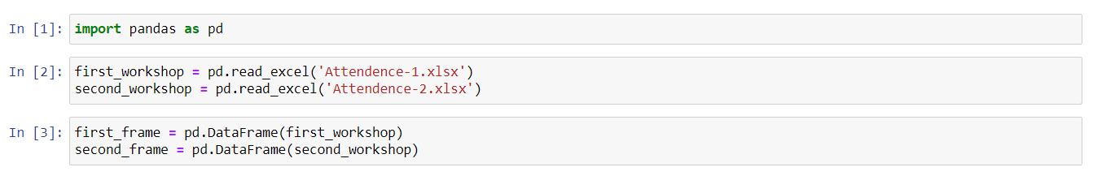

1. **Perform merging of the two dataframes to find the names of students who had attended the workshop on both days.**

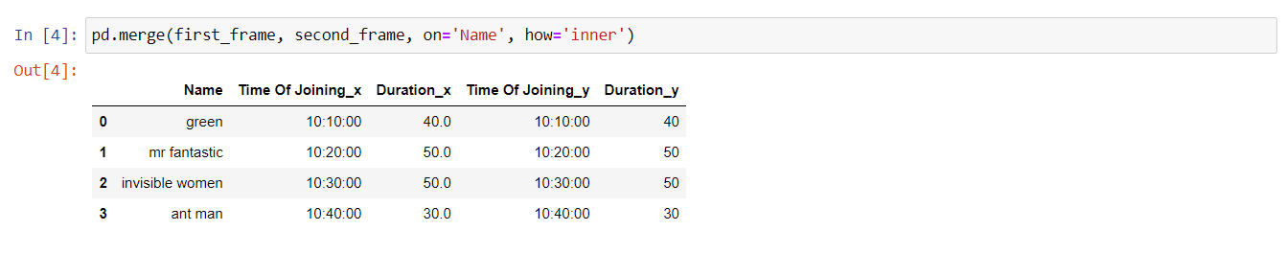

1. **Find names of all students who have attended workshop on either of the days.**



1. **Merge two data frames row-wise and find the total number of records in the data frame.**

